Introduction
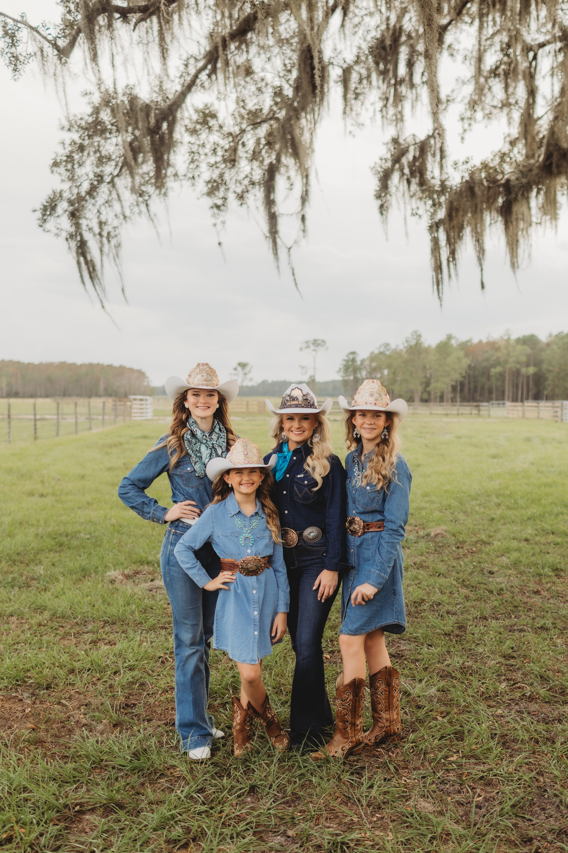  2026 Miss Rodeo Florida Pageant Official Pageant Rulebook | 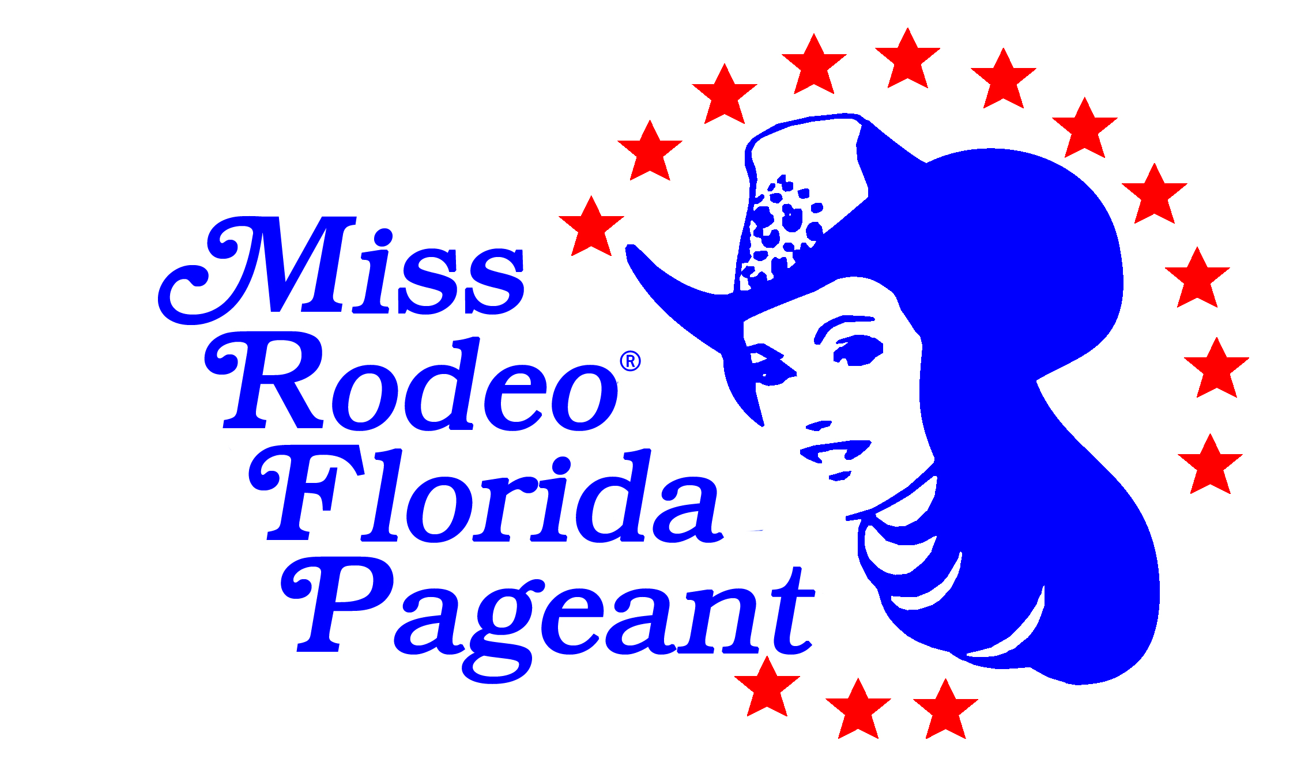  Pageant Rules and Regulations, revised July 2025.  For further information or assistance, please contact: Miss Rodeo Florida Association, Inc. Saria Tenan MissRodeoFLPageant@gmail.com.  Check the website for updates and information. www.missrodeoflorida.com  ALL RIGHTS RESERVED  Copyright © 2025 by Miss Rodeo Florida Assoc., Inc.

Who is Miss Rodeo Florida/Miss Teen Rodeo Florida?
Miss Rodeo Florida/Miss Teen Rodeo Florida symbolizes the youth of our State who wish to further promote the sport of professional rodeo and western way of life. She is the ideal, western-type American girl, and is the person who will represent professional rodeo as she travels our state and country.
What does it mean to be Miss Rodeo Florida/Miss Teen Rodeo Florida?
While spreading good will for her community, her state, and her country, Miss Rodeo Florida/Miss Teen Rodeo Florida is garnering the richest experience of her life and laying a solid foundation for her future. She may receive a scholarship to help further her education along with gifts, donations, and accessories.
The value of Miss Rodeo Florida/Miss Teen Rodeo Florida to her home state is limitless. During her reign, she is the state’s Official Representative of the Professional Rodeo Cowboys Association and should constantly be aware of the values of public relations between the general public and those actively involved in pro rodeo. It is her responsibility to improve the image of the rodeo to all with whom she comes in contact. The experience gained as she travels across her state, and perhaps other parts of the country, can be one which will enrich her life in countless ways.
The value of Miss Rodeo Florida Princess/Miss Rodeo Florida Sweetheart.
The Miss Rodeo Florida Princess/Sweetheart titles are designed as a stepping stone in a young lady’s life to prepare her for future rodeo queen titles and responsibilities. The best way to learn is by hands-on experience shadowing the senior Miss and Teen and will follow the same guidelines and rules as the Miss Rodeo Florida/Miss Teen Rodeo Florida Contestants.
What type of young lady does the Miss Rodeo Florida/Miss Teen Rodeo Florida Pageant attract?
The young lady who wishes to be a leader in her community, and further promote the western way of life on a local, state, and national basis.
The young lady who loves horses and everything they represent, and who wants to show the rest of the world what can be accomplished while surrounded by this environment.
The young lady who wants to act as an official representative of professional rodeo, portraying good sportsmanship and high moral and ethical character, and reflecting careful and humane treatment of animals. She should understand the sport of rodeo in its entirety, enough to be able to explain and “sell” rodeo to anyone with whom she may come in contact, and be able to speak intelligently, with dignity and sincere interest in rodeo. She should realize that the Miss Rodeo Florida/Miss Teen Rodeo Florida Pageant is not a beauty pageant. However, she should act, speak, and dress according to the prestige the title deserves.
The ambitious young lady who is interested in furthering her chosen career.
How can a young woman become royalty for the Miss Rodeo Florida Pageant?
To compete in the Miss Rodeo Florida Pageant, one must meet all requirements set forth in the official pageant rule book for the Miss Rodeo Florida Pageant and the Miss Rodeo America Pageant.
- CONTESTANT ELIGIBILITY: Each contestant in the Miss Rodeo Florida Pageant shall on the date of competition:
  - MRF contestant (20-26) Must be a natural-born female who has reached the age of 21 years by November 1, 2026, and shall not have reached the age of 27 years by December 31, 2026. This must be evidenced by a birth certificate presented before the competition.
  - MTRF contestant (15-19) Must be a natural-born female who has reached the age of 15 years and shall not have reached the age of 20 years by December 31, 2025. This must be evidenced by a birth certificate presented before the competition.
  - MRF Princess contestant (11-14) Must be a natural-born female who has reached the age of 11 years and shall not have reached the age of 15 years by December 31, 2025. This must be evidenced by a birth certificate presented before the competition.
  - MRF Sweetheart contestant (7-10) Must be a natural-born female who has reached the age of 7 years and shall not have reached the age of 11 years by December 31, 2025. This must be evidenced by a birth certificate presented before the competition.
  - If the contestant is not presently enrolled in school, she must be a high school graduate or hold a GED. Contestants must not have previously been or presently be married and/or pregnant.
  - Contestants must be a resident of the state of Florida at least 1 year prior to the date of orientation and shall reside within the State of Florida during the entire year of her reign. Proof of residency must be provided with two forms of documentation (e.g., driver's license, utility bill, lease agreement).
  - Must never have been a prior contestant in the Miss Rodeo America Pageant.
  - Must not be a state or national titleholder of any other pageant in the year of competition.
  - Have executed all consents and/or waivers of liability presented as condition precedents to the competition.
  - Have never been disqualified and/or title forfeited in the Miss Rodeo Florida/Miss Teen Rodeo Florida Pageant or any other state pageant/contest.
  - There is no limit to the number of times an individual can compete in the Miss Rodeo Florida/Miss Teen Rodeo Florida Pageant if the contestant meets eligibility requirements. MRF Association has the right to deny an application.
  - Must abide by all rules and regulations of the Miss Rodeo Florida/Miss Teen Rodeo Florida Pageant.
  - Must never have been convicted or pled no contest to a felony charge.
  - Any contestant not meeting the qualifications set forth above shall be denied the right to compete in the Miss Rodeo Florida Pageant. The Miss Rodeo Florida Association has the final say and right to deny an applicant to compete.
- RULES OF CONDUCT:
- Contestants must conduct themselves in a proper lady-like manner and portray high moral standards at all times.
- Contestants will not be permitted to drink alcoholic beverages, use illegal narcotics, paraphernalia, tobacco products, or use foul language at any time during the pageant.
- Contestants, or any individual related to a contestant, must not approach Judges with the intent to influence or harass.
- Contestants will not be allowed to carry or use mobile devices (phones, apple watches, ipads, ect.) until the completion of the pageant.
- Upon commencement of the pageant, contestants will be under the jurisdiction of the MRFA, Inc. Parents and Friends are encouraged to attend pageant activities but will not be allowed to visit with contestants in their rooms. Any items to be given to the contestants should go through the front desk or chaperones.
- The contestant and her family and friends are expected to display the highest degree of sportsmanship during the pageant and particularly following the Coronation Ceremony.
- Contestants will be well prepared, groomed, dressed appropriately and on time for all activities.
- Contestants will not accept coaching, prompting or assistance of any kind from family or friends during competition.
- Contestants will not leave pageant facility/property at any time during the pageant, unless being escorted by a chaperone or MRFA, Inc. official.
- Failure to abide by these Rules of Conduct may result in disqualification from the competition. Any and all illegal activity will be reported immediately to the authorities.
- LOSS OF TITLE AND BENEFITS:
Subsequent to the Miss Rodeo Florida Pageant, any person being awarded the title of Miss Rodeo Florida/Miss Teen Rodeo Florida, and/or otherwise becoming the successor thereto, shall not:
- Become publicly engaged, married and/or pregnant at any time prior to or during her reign.
- Be charged with and/or determined to have committed any crime of moral turpitude.
- Compete in and/or otherwise participate in any other beauty and/or talent contest, pageant and/or activity.
- Solicit, negotiate, or contract with any third person for appearances, photographs, interviews, sponsorship, and/or endorsement, during the year of her reign without the express permission of the MRFA, Inc. and its Board. Upon the occurrence of any of the above events, the title of Miss Rodeo Florida/Miss Teen Rodeo Florida together with any and all benefits derived by such person, shall be forfeited, and awarded to the next qualified runner-up. If such is discovered after her reign, the winner may be liable for repayment of any cash or awards she may have received during her reign.
- JUDGES:
- There should be three to five judges depending on the number of contestants and is at the discretion of the MRFA, Inc.
- Judges will score all categories of the Pageant. All scores will be totaled for each contestant each time they are judged.
- Should a judge become incapacitated during the pageant, judging will continue with remaining judges, for the remainder of the pageant or until the incapacitated judge can resume.
- Judges are selected for their expertise in all fields of competition. They should all have an awareness of correct western dress, they should be knowledgeable about the sport of professional rodeo, and they should be experienced western-type horsemen and horsewomen who are accustomed to judging horse events.
- JUDGING GUIDELINES: All Contestants will be judged in the following categories: Personality, Appearance, Personal Interviews, Modeling, Impromptu Questions (Rodeo/Personality/Current Events), Most Photogenic, Speech, and Horsemanship Riding Competition. Miss/Teen have further judged categories: Written Test, Horsemanship Interview, and the salesmanship of their live auction item. Most Photogenic and Miss Congeniality are chosen, not scored, and does not count toward contestant’s overall score.
- JUDGED EVENTS:
- Most Photogenic: All Contestants: The judges will score the required color 8 x 10 vertical, head and shoulder professional indoor photograph submitted by each contestant, to determine the winner of this category. Contestants must submit a digital photo of high quality with their application, Indoor photo by Professional Photographer, all same pose, Solid Background, head/shoulder shot, wearing Western Wear to include Western Hat. No outside photos, Tiaras or crowns may be worn. This honor award score is not added into the contestants’ final score.
- Personal Interviews: All Contestants will be interviewed privately. Judges choose topics which may include pageant information, past queen alumni, rodeo knowledge, and information on application, and local/state knowledge. There will be 2 Current Event Questions asked of each contestant. Question scores will be added into the final score.
- Impromptu Questions: All Contestants will be given two rounds of impromptu questions presented during different pageant functions. Immediately following their speech presentation, each contestant will answer two on-stage personality questions designed to showcase their ability to think on their feet, express themselves clearly, and reveal elements of their character. During the fashion show, contestants will be asked two rodeo-related questions to assess their understanding of the professional rodeo events, or the PRCA Rulebook. These questions are intended to evaluate the contestant’s poise, confidence, communication skills, and overall depth of knowledge.
- Written Test: MRF/MTRF: A written test will be given to MRF/MTRF contestants. The test may include but is not limited to aspects of your State, Rodeo, Horsemanship, Equine Science, Current Rodeo Events, Alumni for MRF, Miss Rodeo America, etc. This test is worth 100 points. The results of the test will be added into the contestants’ final score.
- State Speech: MRF/MTRF contestants are required to give a (2) two-minute speech on ―The state of Florida or any aspect of Florida. The contestant with the highest total score in the speech competition will be recognized with a special award and points given on the final score. Princess/Sweetheart: Contestants are required to give a no more than (1) minute speech on: “Why they would like to be Miss Rodeo Florida Princess/Sweetheart”.
- Horsemanship: All Contestants: There will be two go-rounds of the horsemanship competition. Please see below, description of the event. All horses entering the Equestrian Facility grounds are required to have a current health inspection and Coggins test. There will be no do-overs unless requested by the judges.
- Horsemanship Interview: MRF/MTRF/ Princess: Judges choose topics which may include professional rodeo, horsemanship, knowledge of tack, horse care, feeding, diseases, anatomy, etc.; knowledge of professional rodeo, its history, organization, rodeo terminology or vernacularly, explanation of standard events, awareness of PRCA and the WPRA/PWRA championship standings, and goings-on in the pro rodeo world. (Excellent sources of information are available from: PRCA, www.prorodeo.com; WPRA, www.WPRA.com).
- Modeling: All Contestants will participate in two events where the contestant may create their own modeling “T” pattern. Modeling is a scored area.
- Auction Item: MRF/MTRF contestants are required to provide a live auction item with a minimum value of $100, which they will present and sell during the Saturday evening fashion show. They will be judged on their personality and selling style, self-projection, self-confidence, and audience engagement. Princess/Sweetheart contestants are required to contribute a silent auction item valued at a minimum of $50 to benefit the Scholarship Program. They will be judged on personality, creativity, effort, and completion of the assignment.
- SCORING:
- The contestant receiving the highest grand total score, in each of their title groups, for the competition shall be crowned Miss Rodeo Florida/Miss Teen Rodeo Florida/Miss Rodeo Florida Princess/Miss Rodeo Florida Sweetheart. The contestant receiving the second-highest grand total shall be first runner-up.
- Judge #1s score will break the tie for category winners, Appearance, Personality, Speech and Horsemanship. If a tie still remains, Judge #2s score will be used . . . and so on until the tie is broken. A tie for Miss Congeniality will be broken by the second balloting by contestants. A tie for Miss Rodeo Florida/Miss Teen Rodeo Florida and runners-up will be broken by the horsemanship scores; the contestant with the highest score in horsemanship will receive the higher ranking.
- If there is only one MRF contestant, she must achieve a minimum of 80% of the total number of points overall. The contestant must achieve a minimum of 75% points in each scored category (Personality, Horsemanship, Appearance).
- Judge’s Score Sheets: Each judge will place his/her score sheets in a manila envelope, seal the envelope, and sign his/her name across the flap. The judge’s chaperone will collect the score sheets after each scored section and keep them safe until such time as the accountants can retrieve them and tabulate them in private. At the end of the pageant, Judge #1 will meet with the Accountants and bring the three judges’ summary sheets to verify the scores are correct.
- PAGEANT DIVISIONS:
- APPEARANCE: The purpose of this judged division is to select the young lady who rates highest in:
  - Attractiveness
  - Grooming: to include neatness and cleanliness in every detail, such as complexion, hands, fingernails, hair, hat, boots, and other apparel. Meticulous care in general grooming is essential for a young lady to be considered as Miss Rodeo Florida royalty.
  - Photogenic Quality: Judges will have a high quality digital copy of a head and shoulder picture to study of each contestant. A young lady’s strength of character and personality are reflected strongly in her wholesome appearance.
  - Poise and Posture: Lady-like behavior in every situation.
  - Knowledge of Proper Western Attire: Contestants should be aware of what is fashionable western dress, with particular attention given to color coordination (contestants should know how the use of various color combinations can enhance appearance and eye appeal). Judges will be observing how a contestant’s clothes fit and suit her form and personality.
  - Contestants are expected to appear in: Full western attire, at all times, unless otherwise specified. All outfits should include a western hat, boots, and belt. Hat shapes are looked at so go to someone knowledgeable to fit your face.
  - It is mandatory that contestants wear WRANGLER® pants whenever they are in pants.
  - Dresses, skirts, and blouses should reflect a western image. Dresses must be Knee/Tea or Floor Length. Garments and accessories must exhibit a western image.
  - It is not necessary to invest in an excessive amount of expensive clothing. Judges will be looking for versatility and imagination displayed by the contestants.
  - Contestants should be knowledgeable on current trends in western wear manufacturing.
  - HORSEMANSHIP: The purpose of this division is to select the young lady who rates highest in:
- Horsemanship – Control of the horse and how the contestant handles each situation that may occur.
- Balance – Ability to sit steadily in a saddle.
- Position – Hands, feet, and seat placement.
- Mounting/Dismounting – MRF/MTRF/ Princess Form and grace during mounting and dismounting (where applicable).
- Evaluation – The contestant’s understanding and skill will be judged—not the horse.
- Divisions & Rounds:
- Miss Rodeo Florida (MRF) and Miss Teen Rodeo Florida (MTRF) will complete two rounds:
    - Round One: A set pattern selected from one of the three listed in this rulebook. For the first round, the judges will select a pattern from those diagramed in this Rulebook. The selected pattern will be announced to the contestants during the Pageant’s competition. The pattern for the Princess contestants is selected by the Horsemanship committee and announced during the Orientation. At the Judges’ discretion, patterns may be altered due to arena conditions. The judges will discuss any and all pattern alterations with the contestants. In addition to executing the prescribed pattern, contestants may also be required to dismount and remount, carry a flag, and/or perform additional maneuvers on horseback. The reigning Miss Rodeo Florida will demonstrate the pattern, including any alterations and additions, prior to start of the horsemanship competition.
  - Round Two: Freestyle Horsemanship: Contestants will perform a freestyle horsemanship pattern of their own design, not to exceed 1 ½ minutes. This round is intended to showcase the rider’s control, confidence, creativity, and overall presentation on horseback. Each pattern must include a lead change, stop, back up, and a presentation run, completed in any order. Riders are encouraged to make full use of the arena and demonstrate their ability to guide their horse with poise, precision, and showmanship. The use of transitions in speed, direction, and cadence is encouraged, but safety and control should be maintained at all times. Time begins when the horse’s shoulder crosses the gate and ends when the announcer calls “Time is up.” A 30-second warning will be given. At the completion of this round, the contestant will complete with a queen run (hot lap).
  - MRF contestants will draw for stock horses and use tack provided.
  - MTRF contestants will ride their own horse and use their own tack.
- Miss Rodeo Florida Princess (MRFP) will also complete two rounds:
  - Round One: A set pattern. See above. The contestant will complete with a queen run (hot lap).
  - Round Two: Rail Work: For the second round, the contestants will show their equitation and arena presence in small groups, also referred to as “rail work.” The contestant’s overall poise, confidence, appearance, and position throughout the rail work will be evaluated. Position is meant to refer to the contestant’s body position while riding, and how the contestants position their horse relative to the other contestants while riding on the rail. These small groups will not involve more than 12 riders at a time. The groups will receive their working direction and gait instructions from the horsemanship competition announcer. A pageant official will manage the arena to ensure all contestants receive the same opportunity (time) to demonstrate their horsemanship skills. The rail work will include the contestants showing their horsemanship skills at a walk, trot, and lope for both directions of the arena (clockwise and counterclockwise). At the judges’ discretion, the contestants may be asked to execute an extended trot, a stop from any gait, and backing their horses while on the rail. The judges may request the contestants to line up in the arena’s center upon direction from the attending ring steward (a MRF Pageant official), at which time they may request maneuvers such as riding their horse forward and then backing into line, and/or additions to these instructions.
  - Contestants will ride their own horse and use their own tack.
- Miss Rodeo Florida Sweetheart (MRFS) will complete one round only:
  - Railwork. The contestant will complete with a queen run (hot lap).
  - Contestants will ride their own horse and use their own tack.
- Horse and Tack – MRF contestants will draw for stock horses in both rounds, with tack already provided. Staff will assist in adjusting stirrups. MTRF, MRFP, and MRFS contestants will ride their own horses and use their own tack. Contestants will draw for the order in which they compete.
- Stalls – Stalls will be reserved for a fee of $50. All stalls must be cleaned out prior to departure. The facility does not allow dogs.
- Injury or Illness – If a horse is injured or ill and unable to compete, a veterinarian’s certificate must be submitted. The Horsemanship Director will determine if a replacement horse may be used. Stallions are not permitted.
- Restrictions – No parents, relatives, friends, boyfriends, trainers, etc. are allowed in the horsemanship area during competition. No one may warm up or ride the contestant’s horse other than the contestant herself. Violations will result in disqualification. (Lunging is permitted.)
- Attire – All Contestants must wear a Wrangler® pant product of their choice, a solid-colored long-sleeved western shirt (tucked in), western boots, and a cowboy hat. No jackets, vests, or chaps. Clothing should be clean, well-fitted, and minimal jewelry worn. Showmanship and neat presentation are expected.
- Spurs – MTRF and MRFP contestants may use spurs on their own horses. Spurs are not permitted on draw horses. (Note: Spurs are not allowed at the Miss Rodeo America Pageant.)

- PERSONALITY: the purpose of this division is to select the young lady who rates highest in:
- Intelligence: Good common sense.
- Education: Ability to speak about rodeo and other areas, with special emphasis on grammar and enunciation.
- Attractiveness: not necessarily to mean beauty in this sense, but rather should note whether the contestant radiates self-confidence without making an issue out of it. To include the contestants’ style of attire, overall appearance, magnetism and eye appeal.
- Personality Reflections: Conversational ability. She should show maturity, high moral standards, sincerity, and integrity.
- Genuine interest in other people: in the pageant and in rodeo, and a noticeable consideration for others.
- Self-projection: Ability to project one’s personality, whether it is from horseback in an arena, on television, or before an audience. Also, to be considered are a sense of humor, showmanship, ambition, desire and enthusiasm.
- Happy outlook on life in general.
- Promptness in keeping pageant schedule.
- Public Appearances- includes public appearances of contestants; giving them an opportunity to speak to an audience with facts and interesting information about their hometown, and/or their state. These appearances may be made at western fashion shows, civic group luncheon programs, evening meetings, banquets, etc. Contestants will be expected to answer questions in at least one of their public appearances, with these questions prepared in advance and drawn by the contestant or an MRF/MTRF pageant official. Some possible subjects include rodeo terms to define, rodeo events to explain, extemporaneous questions, all of which require the contestant to think on her feet, and show maturity, intelligence, wisdom and imagination.
- Judges will be provided a copy of the pageant application and photo in advance of the pageant.
- MISS RODEO FLORIDA PAGEANT REQUIREMENTS:
- Entry Fees: Miss Rodeo Florida (Ages 21-26) - are $300, Miss Teen Rodeo Florida (Ages 15-19)- are $250, MRF Princess (Ages 11-14) – are $200 and MRF Sweetheart (Ages 7-10)- are $200. Our application process now exclusively operates online, with the deadline set for September 25, 2025. Applicants are required to upload a professional headshot digitally as part of the application process, along with a photographer's release. Age and residency verification will occur at the mandatory clinic (date will be sent out to contestants), where participants must present their birth certificate and provide two proofs of residency. These updates aim to streamline the application process and ensure compliance with our eligibility criteria.
- Chaperones: The MRF contestants will be under the supervision of the MRF Assoc., Inc., and Pageant Chaperone(s) from the time they arrive until they are signed out by Pageant Officials. The chaperones will escort the MRF contestants from the hotel and the other contestants while on pageant property to and from all functions during the pageant. Chaperones duties will consist of making certain the contestant’s schedules and other responsibilities are met. The number of chaperones will depend on the number of contestants – a suggested guideline is one chaperone to every five contestants, with one head chaperone having full responsibility. The Teen, Princess and Sweetheart contestants will follow the same schedule as the participants in the older divisions. They will check-in and depart just as the Miss contestants, but they will be under the supervision of their parents when not competing or on pageant property. Parents are responsible for transporting their daughters to functions and for getting them there on time. While competing, ALL contestants will be seated together and supervised by the Chaperones and some of the pageant committee. However, parents are asked not to approach their daughters until authorized by pageant personnel. We want to be as organized as possible. All contact and delivery of needed items, or messages with the MRF contestants will be done through the chaperones. Cell phone numbers will be given out during orientation.
- Parents/Relatives: Parents and relatives of MRF contestants are welcome to attend certain events at which the contestants will be present. However, after the pageant begins, contestants cannot communicate with family, friends, or boyfriends unless authorized by the chaperones.
- Transportation: All transportation needs for MRF contestants to functions shall be provided. Transport of Teen/Princess/Sweethearts will be the responsibility of the parents.
- Horsemanship: All Contestants - There will NOT be any parents, relatives, friends, boyfriends, trainers, etc. allowed in the horsemanship area or arena during the competition. Also, there will be NO one on and/or warming up the contestants’ horses. If so, the contestant will be disqualified.
- Video recording and photography equipment are allowed at the Pageant functions, unless directed otherwise by pageant officials.
- Judging will take precedence over all pageant activities, beginning at the Orientation meeting for the contestants and continuing throughout the pageant.
- All Contestants will be required to stay together for the duration of the pageant unless there is cause for emergency release. Contestants must receive approval from MRFA, Inc. officials before departure.

- DRESS CODE FOR PAGEANT EVENTS:
- NO crowns or sashes will be worn during any portion of the pageant, including any non-judged events.
- Photogenic: Outfit of your choice, 8x10 color head-and-shoulders photo. Pictures must include a western hat, western styled outfit, belt and boots (NO tiara, crown or banner).
- Check In /Orientation All Contestants – Wrangler Pant Product of your choice (any color), Western long sleeve blouse with, any color, blouse may be embellished, shirt tucked in, western boots and cowboy hat. Even though you are not being judged, judges will still see you at lunch.
- Rehearsal / Lunch: All Contestants Same as Orientation.
- Personality Impromptu Questions and Speech: All Contestants Western business attire: A modern, professional dress/skirt/slacks paired with a blouse and/or jacket or vest. Skirt or dress length should be no more than 2 inches above the knee. Outfit must be worn with boots, a cowboy hat, belt, and buckle, and should be appropriate for a professional speaking engagement.
- Personality Interviews: All Contestants Same outfit as Speech
- Horsemanship: All Contestants Horsemanship Outfit: Wrangler Pant Product of your choice, long sleeve shirt tucked in (shirt may be embellished), western boots and cowboy hat. All riding attire should be neat and fit properly. Minimum jewelry should be worn. Showmanship should be considered, since a contestant’s personality projects from horseback to the audience and judges. No Chaps or spurs unless Teen contestant is on personally owned horse.
- Horsemanship Interview: MRF/MTRF/MRFP –Same outfit as horsemanship. Vests or jackets are optional and may be embellished.
- Fashion Show Dinner: All Contestants Wear Wrangler Jeans and Dance Shirt for Arrival. Western Elegance dress/skirt with blouse and/or jacket/vest, boots, cowboy hat, belt & buckle All may be embellished.
- Coronation: All Contestants Same attire as fashion show. No changes.
- Miscellaneous Attire
    - Wrangler pant product means any fabric or style of pant that is manufactured by Wrangler®.
    - Out of respect for the current Miss Rodeo Florida royalty, no crowns are to be worn.
    - Consult the MRF Pageant Director or National Director for any questions on “Full Western Attire.”
- AWARDS PRESENTATION:
- All contestants MUST attend the Awards Presentation. Should a contestant not attend, she will automatically forfeit her award and/or scholarship. All Prize Packages will not be taken at the pageant and will be given at the time of contract signing. Date and time TBA.
- PAGEANT WINNERS:
- All four Queens and the MRF/MTRF First Runner Ups of the Miss Rodeo Florida Association, Inc., pageants will be required to sign a contract between herself and Miss Rodeo Florida Assoc., Inc. at a later date designated by the MRFA. All Prize Packages will not be taken at the pageant and will be given at time of contract signing.
- Must provide MRFA, Inc. with, but not limited to: Valid Driver’s License, Proof of Insurance for vehicle and Health Insurance.
- MRF/ MTRF/ Miss Rodeo Florida Princess/Sweetheart reign will begin on January 1, directly following the pageant and will end on December 31 of the same year. (MRF will take possession of crown, travel chaps, etc. on or before January 1st).
- Florida is eligible to send one contestant only to the national pageant, with approval by Miss Rodeo America, Inc.
- The winner of the MRF pageant will be required to compete in the Miss Rodeo America Pageant in the year of her reign.
- No future contestant (Lady-In-Waiting) in the Miss Rodeo America Pageant shall be allowed to attend any official function of MRAI (ex: MRA Board/National Director and/or National advisory meetings, etc.) They will be allowed to attend only those activities open to parents and the general public.
- Miss Rodeo America Pageant – MRF-Lady in Waiting is required to attend the MRA Pageant in Las Vegas, Nevada during the same year after her pageant. She will be required to pay for her own transportation, lodging, tickets to the MRA functions, as well as any personal expenses. She will not be allowed to wear her banner or crown during MRAI events.

- FORMAL COMPLAINT/GRIEVANCE PROCESS:
Any formal complaint related to the Miss Rodeo Florida Pageant must follow the detailed process below. This process is designed to ensure thoroughness, transparency, and fairness. Complainants should understand that filing a grievance opens a formal inquiry that will be conducted according to the following stringent protocols.
- Submission Requirements
  - All complaints must be submitted in writing via email or certified mail within 48 hours of the incident or announcement of results. Complaints received after this time will not be considered.
  - Pageant Director, Missrodeoflpageant@gmail.com
  - National Director, MRFNationalDirector@gmail.com
  - The complaint must include: The complainant’s full legal name, residential address, email address, and phone number for verification. A detailed account of the concern, including specific facts, times, and evidence supporting the complaint. Specific rule(s) or procedure(s) the complainant believes were violated. If the complaint relates to scoring or results, the complainant must clearly outline the specific portion of the results they believe to be incorrect.
- Initial Review and Verification
  - The National Director will acknowledge receipt of the complaint within 72 hours.
  - A formal written notification will be sent to all parties involved (e.g., contestants, judges, auditors), informing them that a grievance has been filed.
  - No media or public disclosure of the grievance is permitted during the review process. Any violation will result in immediate dismissal of the grievance.
- Engagement of External Auditors
If the complaint concerns scoring, results, or discrepancies in the outcome, the following steps will be initiated: The Board will engage an independent third-party accountant (qualified by holding a CPA designation or having verifiable experience in pageant or event auditing) to conduct a full review of the scores and results. This auditor must meet the following qualifications:
- No prior involvement in the pageant or any related event.
- A background in financial auditing, event scoring verification, or similar fields.
- The auditor will be provided with all original scorecards, judging sheets, and related materials to conduct their review.
- The second opinion auditor must also meet these qualifications and will act independently of the initial auditing team. This second auditor may be engaged through a different firm to ensure impartiality.
- Both auditors will have 48 hours to complete their reviews, though the process may be extended based on complexity. The complainant will be notified if more time is required.
- Judges’ Review
- As part of our protocol, after the scores are verified by the accountant, the judges will reconvene to review the final results to ensure they have no concerns about the accuracy of the scoring.
- The judges' final validation, along with the accountant’s verified scores, will form the official record of the results.
- Final Report and Notification
- Once the second audit is complete, a formal report detailing the findings will be prepared by the external auditor. This report will be reviewed by the Executive Board.
- The Executive Board will make the final determination based on the findings and, if necessary, corrective actions will be taken.
- The complainant and all involved parties will receive a final written decision within 10 business days of the second auditor’s report. This decision is final and non-appealable.
- Penalties for False or Malicious Complaints
  - Any complainant found to have knowingly submitted a false or malicious complaint will be permanently disqualified from future pageants and may be subject to legal action for defamation.
- Strict Confidentiality
  - Throughout this process, strict confidentiality will be maintained. If the complainant discusses the matter publicly, on social media, or with the press, the grievance process will be nullified, and no further action will be taken.
- Media and Public Disclosures
  - No party involved in the grievance, including the complainant, contestants, judges, or auditors, may contact the media, including social media platforms, about the matter until the grievance is resolved. Violation of this policy will invalidate the grievance.
- Definition of Qualified Second Opinion Auditor
  - Certified Professional Accountant (CPA) with at least 5 years of experience or a similar designation relevant to event scoring or auditing.
  - No prior connection to the Miss Rodeo Florida Pageant or any individual involved in the contest (e.g., judges, contestants).
  - Expertise in auditing practices and procedures, especially in event-based or pageant auditing, to ensure accuracy and fairness.
- Final Decision and Reporting
  - The decision of the Executive Board based on the external auditor’s report is final and non-appealable. No further grievances on the same matter will be accepted.
  - Any complaints that do not follow the above process will be classified as defamation of character and invalidity.
- MRF ASSOCIATION FOLLOW-UP PROCEDURE:
- All complaints will be reviewed by the Executive Board. An Executive Board member will be assigned to research and gather information about the situation. All parties involved will be notified about the complaint and given the opportunity to provide a response.
- A time frame will be established for the issue to be addressed.
- Findings will be reported back to the Executive Board.
- The Executive Board will vote and determine the necessary action to be taken.
- An Executive Board representative will report back to all parties involved.

MISS RODEO FLORIDA ASSOCIATION, INC.
MISSION STATEMENT

It is the mission of the Miss Rodeo Florida Association, Inc., to produce a professional state pageant for the purpose of selecting a Miss Rodeo Florida and, Miss Teen Rodeo Florida. who will serve the great state of Florida as official ambassadors and spokeswomen for the professional sport of rodeo and our western traditions. By recognizing the importance of promoting a positive image and awareness of rodeo while preserving our western heritage, our goal is to support, guide, educate, and offer direction to these young ladies so that they may be better prepared to serve with the highest level of integrity and professionalism, as role models, to educate the public as they travel throughout the state and across the nation. It is also our purpose to assist, support and groom the reigning Miss Rodeo Florida for the ultimate challenge of competing in the Miss Rodeo America Pageant as the official representative from the State of Florida.

